User Interface

The website will have four main pages. These are Homepage, Calculator, Tally Counter and Clock

This is the front end that the user will interact with and able to use the website

1. Homepage

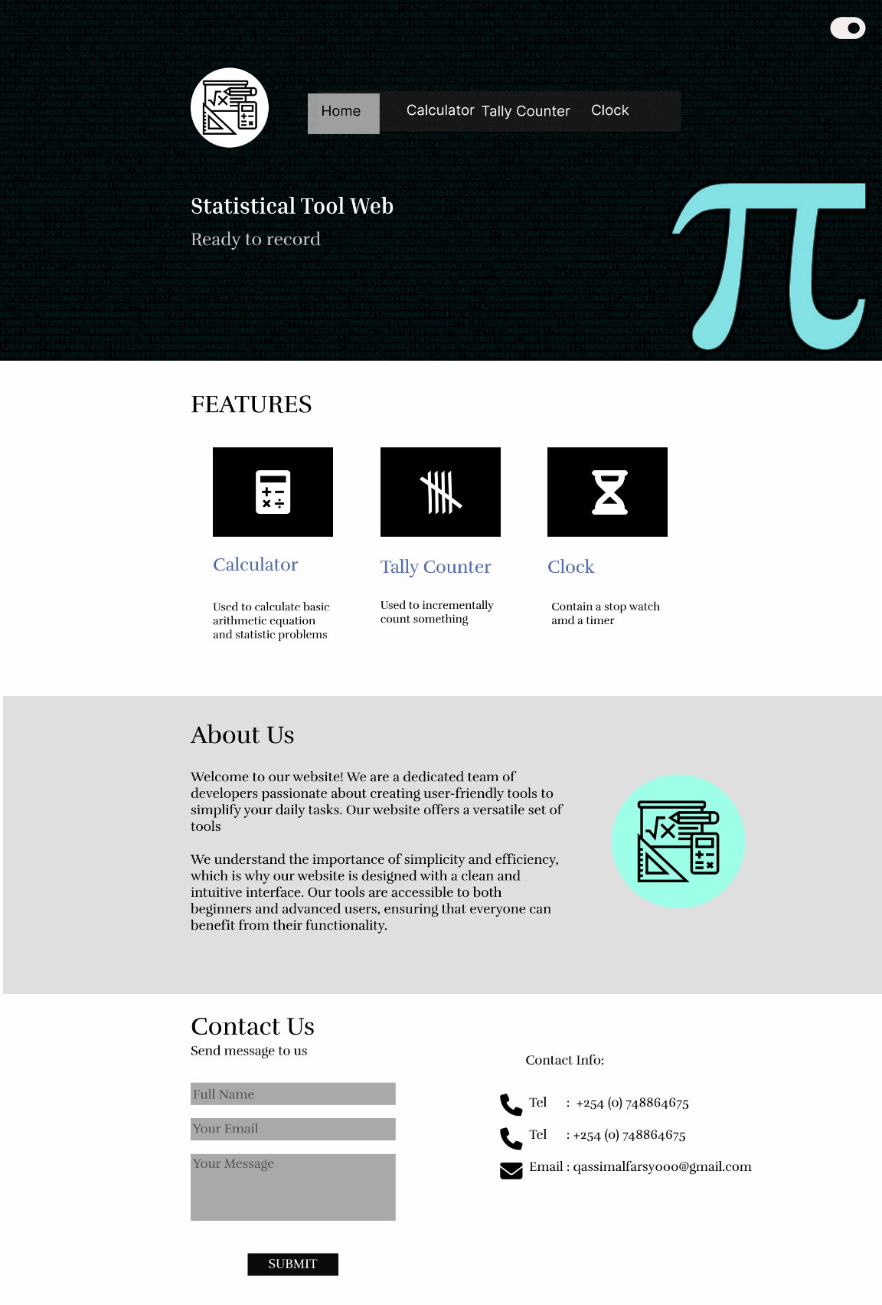

This is the homepage it contains the header, features, About us and the footer.

The header has The website logo, menu bar that can enable to navigate through pages, the hero header and a toggle button to change the theme.

Features shows the available operations in the website.

About Us is chows the objective of the website.

The footer contains the contact information and a form to contact the developer.

1. Calculator

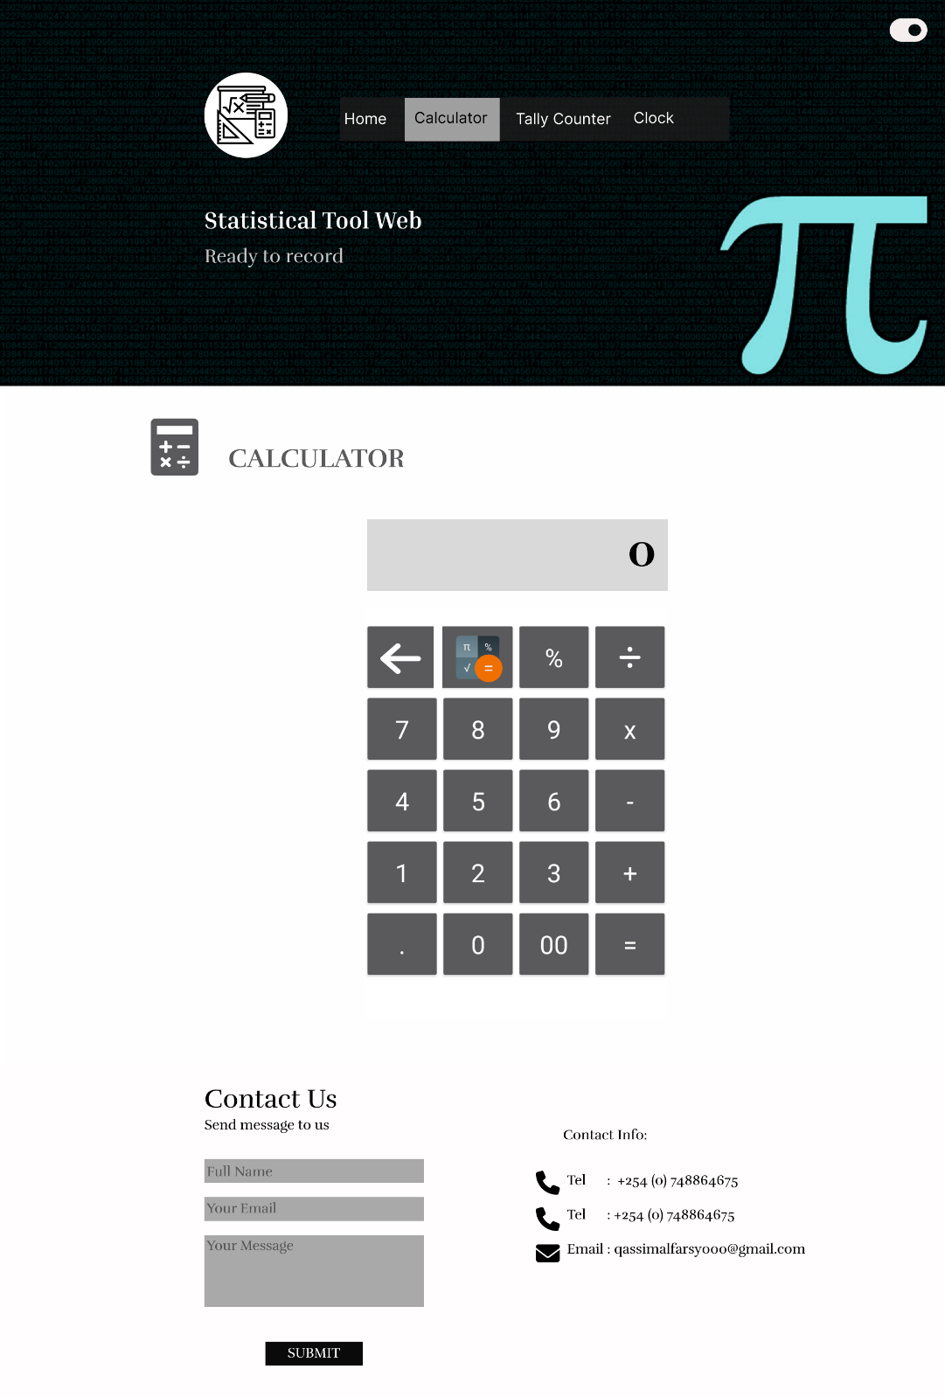

The calculator page contains the header, a calculator and footer.

The calculator is able to do the following function:

Addition, subtraction, multiplication, and division are the fundamental operations of mathematics.

Exponentiation, logarithms, square roots, trigonometric functions, and more are examples of advanced functions.

Input and output displays that are both clear and easy to read.

1. Tally Counter

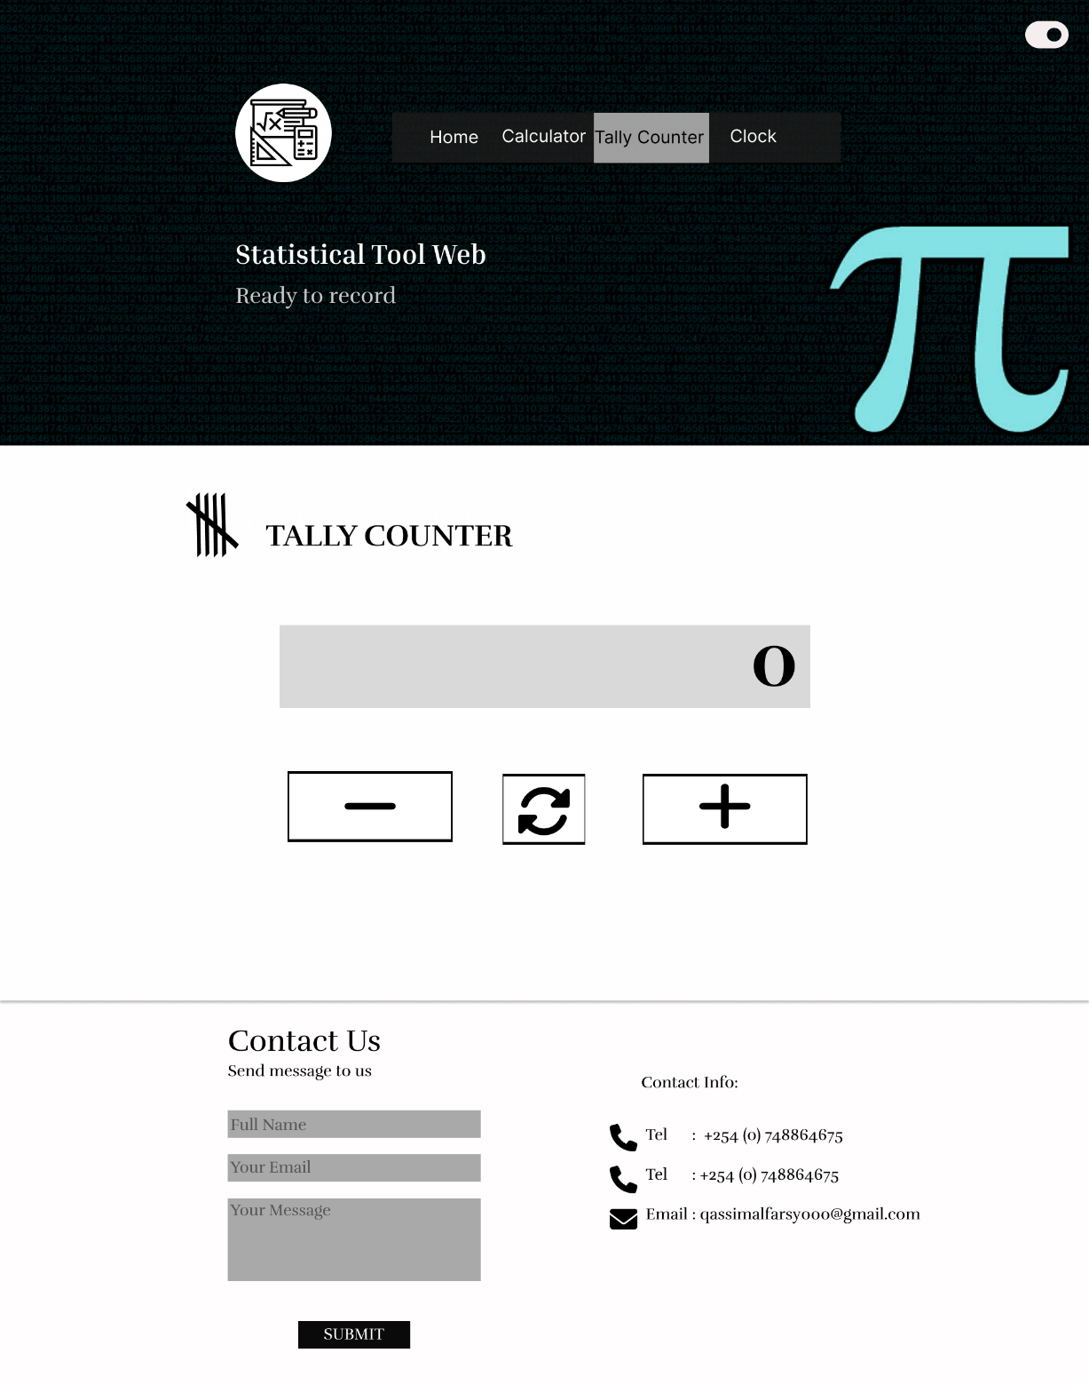

The tally counter page contains the header, a counter and footer.

Tally Counter is able to do the following function:

Click-based simple counting to increase the count by simply click on the counter.

Reset choice: Reset the counter to 0 to begin counting again.

1. Clock

The clock has two button, a button for the stopwatch and the other is for the time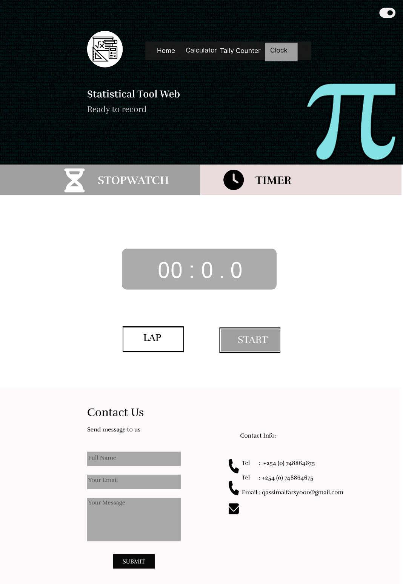

The stopwatch page contains the header, a stopwatch and footer.

Stopwatch is able to do the following function:

Accurately start, stop, and record the amount of time that has passed.

Record several lap times during a timing session using the lap feature.

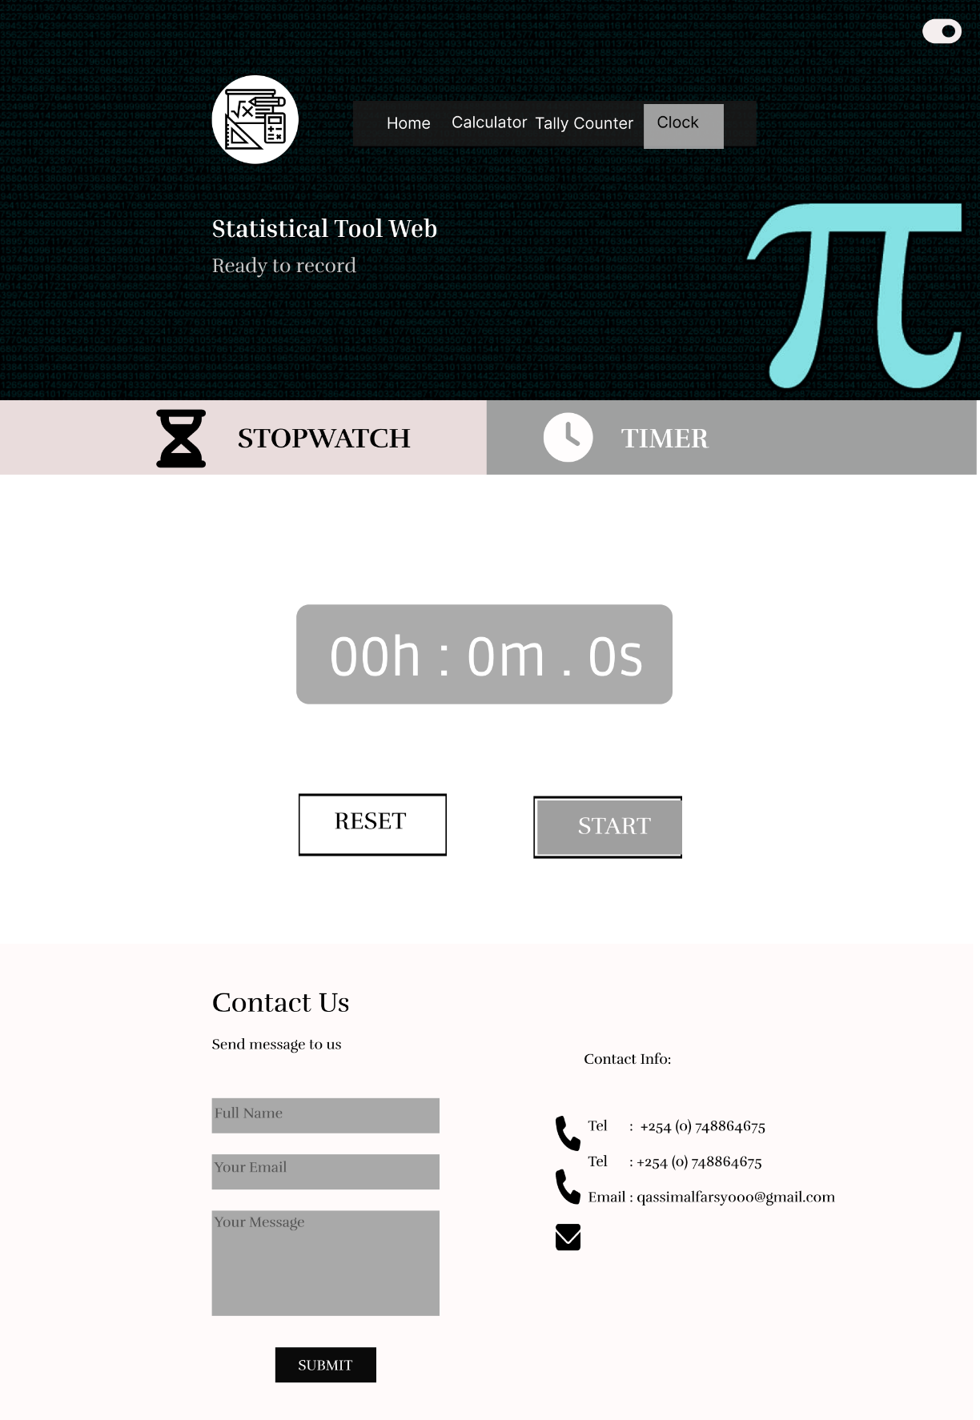

Timer is able to do the following function:

Set countdown time: Give the timer a duration that you want it to run for.

Audible alert: Receive sound notification when the timer hits zero.

Pause and resume capabilities: When you're ready, restart the timer after taking pauses.